Mel Orgee – Chair of Governors - Foundation Governor
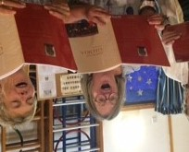
I joined the governing body at Bromesberrow St Mary’s in 2015 as a Foundation Governor. I acted as vice-chair for a couple of years and had the pleasure of being elected as Chair in September 2018.The Foundation role was right for me because Christian values were an important part of my own upbringing. I feel that children gain so much from being educated as part of the local community with the church at the centre. I very much enjoy reading at services at Bromesberrow St Mary’s throughout the year.
My association with our school has been a long one – my teenage daughter came to the school from the age of 2 and I worked at the school nursery myself for five years. After my daughter had moved to secondary school and I had moved to work at a different nursery, I was pleased that the role of governor maintained my links with a school that means so much to me.
I have qualified as an Early Years Teacher and am passionate about how a strong, holistic start in early years can prepare children for the rest of their education. Supporting young children to think for themselves, express their own ideas and to develop an eagerness to enquire and learn is the greatest gift that children can receive.
Music is a strong thread running through my hobbies and interests. I sing with Tewkesbury Choral Society, which brings the pleasure of singing two concerts a year in the beautiful Tewkesbury Abbey. I have also recently taken up Morris dancing. I am reminding myself how to find my way around the piano and exploring folk tunes on the recorder.
This academic year I will be building my own skills, attending training on leadership and mentoring and fulfilling the role of a strong chair. l will continue to develop relationships with chair of governors at the local secondary school and at other primary schools to exchange experiences and expertise. I will remain as the Early Years link governor, continue to feed parents’ opinions into aspects of school life and analyse the school development plan to adapt and improve further extend children’s experiences at school. I have seen how the education from Bromesberrow St Mary’s can give children a solid foundation for the next stage in their lives and am committed to supporting staff and children to see that this continues.

Natalie Crickett – Vice Chair - Parent Governor
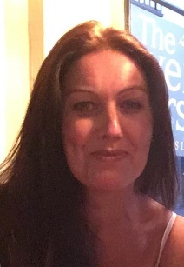
I have been a parent governor at Bromesberrow St Mary’s School for 3 years. My son Archie is in year four and has happily attended the school since the beginning of year one. Within my role of parent governor, I have responsibilities for the vulnerable and SEND children. I am very passionate about mental health and wellbeing which spurred me to complete a psychology degree and more recently a Master’s degree in counselling psychology. I think children’s pastoral care is of great importance and consider the care given at Bromesberrow St Marys to be of a high standard. Furthermore, I believe all children irrespective of their background have the right to fulfil their full potential.
In addition to Archie I am kept busy with three further children. I currently work at Eastnor Castle and also volunteer with the Youth Justice Service in cooperation with West Mercia Police and Worcester University to assist troubled youths. I understand the need for self-care and in my spare time I enjoy keeping fit, I am a committed player in a local netball league and frequently visit the gym.

Debbie Clueit – Foundation Governor
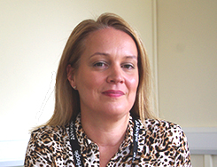
My role on the Governing Body is that of a Foundation Governor. I have been in this role since April 2018, working with other Governors and Staff to drive the Christian Values of the School. I attend Church regularly in the wider community and enjoy participating in services at Bromesberrow St Mary’s throughout the academic year.
I currently have a daughter in Key Stage two, who has attended Bromesberrow St Marys from the age of 2 years old, where she started school life in the nursery. My son also attended Bromesberrow St Marys from Year 2, until transition to secondary school at the end of Year 6.
My work experience in Education, spans more than 24 years. My time is currently split between Local Authority and Self Employment. Designing and delivering training to a wide range of client groups, including the NHS, schools, private businesses, social workers and care sector employees. I specialise in Health and Safety, First Aid and Safeguarding Adults and Children. I am able to bring my skills and knowledge in these areas to my role on the Governing Body, with key focus around Safeguarding and H&S in the School setting.

Laura Hankins – Headteacher Governor
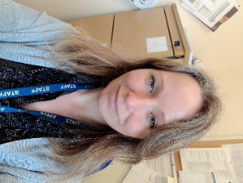
I am one of the Headteachers at Bromesberrow School. I have been at the school since 2009 and have always loved working here. I have two children, a boy (who attended Bromesberrow) and a girl and family time is really important to me. I have a dog called Oscar, who always puts a smile on my face, apart from when he raids my bin! I love the great outdoors, camping and walking. I try hard to eat well and deep fit, although this is sometimes a lofty ambition! Gardening is a passion of mine and I enjoy growing fruit and vegetables to eat, as well as flowers, just to look and smell beautiful. I also keep a small flock of chickens and love watching them scratching about.

Leonie Mison – Staff Governor
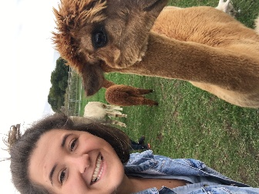
I joined the Governing Board, as a Staff Governor in 2018, to be able to further my understanding of how our school works. With the guidance and support of the school governors, the staff work extremely hard to create a safe and inspiring environment for our children and I am grateful for the opportunity to represent the views and ideas of the teaching team.
My passion for teaching has driven me throughout my own education and led me to complete a degree in Education at The University of Gloucestershire and then continuing to complete my PGCE. For me it was always important to understand Education in its entirety not just in practice. Throughout my degree, I volunteered at a local primary school in their Reception class and during the holidays I worked in a local nursery near my home. During my PGCE year, l I taught in a year 5 class and then continued my training practice at Bromesberrow St Mary’s in Class 2 and then in Class 3. The experiences I had throughout my education, have given me a broad understanding of children’s developmental and educational needs.
In my spare time, I enjoy taking the time to relax by reading (preferably in a hot country) and travelling to new places with my friends and family. I have loved playing, and watching netball and it is something I am aiming to get back into. If there is a dog nearby, you will most definitely find me with it!

Derek Partridge – LA Governor

I’ve lived in Ledbury for over 20 years and worked in a professional capacity in the financial services industry for over 25 years. This provided me with a skillset including project work, influencing skills, budget knowledge / accountability, recruitment including shortlisting and interviewing, coaching, mentoring, guidance and support. I’m naturally inquisitive and solutions-focussed, and willingly question / challenge others to secure good outcomes. With four children, I know first-hand the impact that a great school education can have, and I am relishing the opportunity to help our school. On a personal level, I love spending time with the family, am a keen tennis player & snowboarder, and regularly watch live music and our closest league football team!

Barbara Messham – Ex Officio Governor

Derek Barnes – Foundation Governor

Julia Bracewell – Parent Governor

