Newsletter No. 3 14th November 2019

Tel: 01531 650340 e-mail: admin@st-marys-bromesberrow.gloucs.sch.uk
Follow on Twitter - @bromesberrow Website www.bromesberrowschool.co.uk

Bromesberrow News
Curriculum News
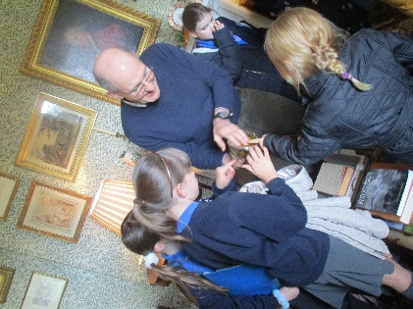
Class Three had a wonderful visit to Bromesberrow Place this week. Dr Greenall and his partner so kindly opened the doors to their beautiful home to share with us an important part of our local history. The children were able to explore artefacts and antiques from the past, including some wonderful family heirlooms passed down from the Albright family through the generations. The children have learned that it is no coincidence that the road to the school is Albright Lane, and that Bromesberrow Place, the estate, school and church have a 251 year association! We learnt about some of the ways the estate has changed over the years-it used to employ between 200 and 300 workers and now has only 2! Here are a few photos sharing our experiences:
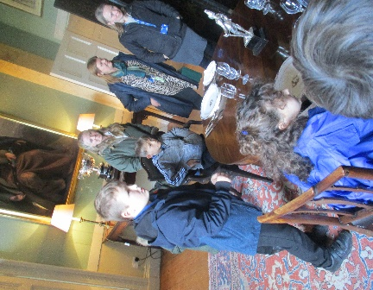
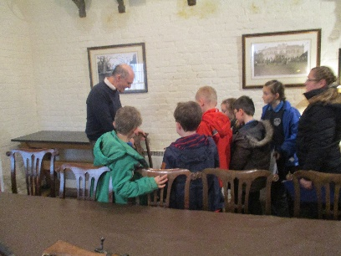
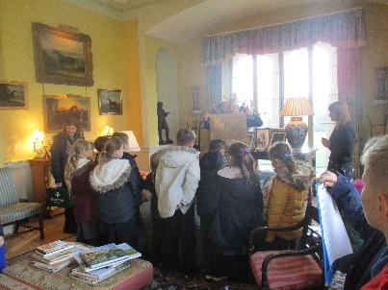

Celebration Assembly 26th November, 9.10-10am
We will be having our celebration event in school to share with all our parents and families what we have been learning about this term. The children have been working really hard to prepare for this and are looking forward to sharing with you. Please come along and see what we do and stop for some refreshments and a chat afterwards in the school hall.
Ledbury in Bloom
We are the proud winners of Ledbury in Bloom Planting Competition. In the summer term we were asked to plant and nurture some seedlings over the course of a few weeks ready to be used by the Ledbury in Bloom committee. Our plants were judged to be the best overall and we were presented with a beautiful glass trophy and some tokens to use at the Garden Centre. We will be entering next year.

Star of the Month
Well done to Ted in Class 2 for being the school’s October Star of the Month.

Children in Need Day
Thank you for your donations towards Children in Need. Today we have collected £164.

Save the Children – Christmas Jumper Day – Friday 13th December
To raise funds for Save the Children, we ask that the children wear either a Christmas Jumper if possible or their favourite jumper and donate £1 to Save the Children.
School Photographer
Everyone should now have proofs of photographs for individual, family group, class and school photographs. We have had some trouble with the website administration of Tempest Photography but all the photos should now be able to be viewed and ordered on the Tempest website. To ensure that you do not have a late order payment please ensure that you have either ordered online or given the order and payment back to the school office by Tuesday 19th November at the very latest. Your feedback on the quality of the photographs would be appreciated so that we know whether to continue with Tempest Photography.
BFG
We have a busy Christmas period organised by the BFG and no doubt we will be asking for volunteers to help nearer the time.
Movie Night - Monday 2nd December 3.15pm – 5.15pm
Tickets will be on sale soon at £2.50 per ticket to include refreshments.
Choir at Tesco – Wednesday 4th December 3.45pm – 4.45pm
The choir will be singing carols in Tesco, Ledbury. We will need parents of the choir to take the children to Tesco and are very welcome to stay and listen. We would also love to see school parents doing their shopping at this time as well to see some friendly faces!
Christmas Story Telling Event – Tuesday 17th December 4.30pm -6pm with special guest. Details to follow.

Scholastic Books

Attached to this newsletter is a Scholastic Book Club catalogue. If you would like any of the books which are available at very good prices, please either order online or get the order back to us by Friday 29th November (the order form is on page 12 of the catalogue), to ensure that the books are back in school before we break up for Christmas holidays. If you would like the books to be given directly to you rather than the children please let the office know.

Dates for the Diary:
Tuesday 26th November Celebration Event in school hall –(9.05am)
Friday 29th November School Reports out to parents
Monday 2nd December BFG Movie Night 3.15 -5.15pm
Wednesday 4th December School Choir at Tesco 3.45pm – 4.45pm
Tuesday 10th December Class 2 & Class 3 Christmas Performance 1.30pm in Village Hall
Wednesday 11th December Class 2 & Class 3 Christmas Performance 6pm in Village Hall
Thursday 12th December Class 1 Christmas Performance 2pm in School Hall
Friday 13th December Christmas Jumper Day (Save the Children)
Thursday 17th December BFG Christmas Story Telling Event 4.30pm – 6pm
Friday 20th December Last day of term (Break up at 2pm)
23rd Dec – 3rd Jan Christmas Holidays
Monday 6th January 2020 Inset Day (Children not in school)
Tuesday 7th January Back to School
Monday 20th January Choir to Young Voices (Birmingham)

Respect
Perseverance
Pride
Cooperation
Motivation
Kindness

