Safety, Health and Environment (SHE)

GCC COVID-19 RISK ASSESSMENT PROCESS FOR SCHOOLS (FROM STEP 4)

This is an update of the GCC COVID-19 Risk Assessment to support schools and educational settings in Step 4 of the Government Roadmap from 19 July 2021*. The aim of the risk assessment is to implement protective measures in the government’s operational guidance to protect your staff, pupils and community.

This update has moved away from the Assess – Plan – Do – Review model previously used (see below) into a more traditional risk assessment format that identifies each hazard, who is at risk, guidance on what you should be doing and any further actions that are required.
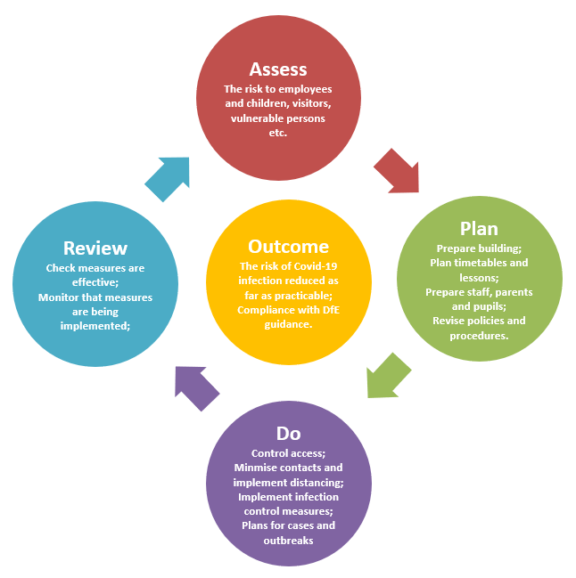
Each school/setting must consider their own situation and adapt the assessment by editing the measures where appropriate. Remove any measures that are not relevant or will not be applied in your setting and add any additional local measures that you are implementing, then complete the relevant columns.

Some people at work may have particular characteristics meaning they are at comparatively increased risk from COVID-19 (due to age, deprivation, ethnicity, pregnancy, etc.) and as employer the school must consider them in their risk assessment.

*Please note that this risk assessment may be updated before September 2021 in light of updates to government guidance.

Reviewed January 4th 2022

COVID-19 Risk Assessment for Schools & Educational Settings

Risk Assessment for Bromesberrow St Mary’s School
Hazards | Who is at risk? | What are you already doing? | Is enough to manage the risks? | What further action is necessary? | Action by whom? | Action by when? | Done
Person showing symptoms or positive test result | Employees  Pupils  Young People  Families  Contractors  Visitors  Members of the public | - Refer to GCC COVID Response Checklist and public health advice on testing, self-isolation and managing confirmed cases of COVID-19.  - Regular communications that persons are not to come into school if they have symptoms, have had a positive test result or other reasons requiring them to stay at home due to the risk of them passing on COVID-19 (e.g. they are required to quarantine).  - If anyone in your school develops COVID-19 symptoms they will be sent home.  - An unwell child awaiting collection will be isolated in a suitable room with or without adult supervision (depending on age and needs of the child).  - Staff caring for a child awaiting collection to keep a distance of 2 metres.  - PPE to be worn by staff caring for the child, including:  - a face mask worn if a distance of 2 metres cannot be maintained.  - if contact is necessary, then gloves, an apron and a face mask should be worn  - eye protection where there is a risk of fluids entering the eye, for example, from coughing, spitting or vomiting.  - Staff to wash their hands after caring for a child with symptoms.  - All areas where a person with symptoms has been to be cleaned after they have left.  - If there are more than 5 positive tests or 10% of staff/children in one class test positive, or control measures are not working, the school’s outbreak management plan will be initiated. School has sufficient supplies of PPE, face coverings, cleaning materials and hand washing/sanitising liquids.  - Update staff, pupils, stakeholders and visitors on changes in practice – Step 4 measures.  - If a parent/carer insists on a pupil attending your school with symptoms, Headteacher may refuse the pupil if, in their reasonable judgement, it is necessary to protect other pupils and staff from possible infection with COVID-19.  - Children who are named as close contacts to LTF daily for 7 days – if negative results children can still attend setting. | Y | Increase the use of home testing by staff (primaries)  Consider reintroducing face coverings and bubbles temporarily depending on infection rate locally.  Attendance restriction will only be recommended by the government as a last resort. | LH/LM  LH/LM | Sept 2021
Poor Personal Hygiene | Employees  Pupils  Young People  Families  Contractors  Visitors  Members of the public | - COVID-19 posters/ signage displayed.  - Frequent and thorough hand cleaning is regular practice.  - Pupils and staff to clean their hands when they arrive at school, when they return from breaks, when they change rooms and before and after eating.  - Sufficient handwashing facilities are available.  - Where there is no sink, hand sanitiser provided in classrooms.  - Skin friendly skin cleaning wipes used as an alternative to hand washing or sanitiser.  - Staff help is available for pupils who have trouble cleaning their hands independently (e.g. small children and pupils with complex needs).  - Use resources such as “e-bug” to teach effective hand hygiene etc.  - Adults and pupils are encouraged not to touch their mouth, eyes and nose.  - Adults and pupils encouraged to use a tissue to cough or sneeze and use bins for tissue waste (‘catch it, bin it, kill it’).  - Tissues to be provided.  - Bins for tissues provided and are emptied throughout the day. |  | Put in place monitoring and supervision to make sure people are following any controls you have in place, including enhanced cleaning. | LH/LM | September 2021
Spreading coronavirus from contact with surfaces, equipment and workstations | Employees  Pupils  Young People  Families  Contractors  Visitors  Members of the public | - Reduced clutter and removing difficult to clean items to make cleaning easier.  - Cleaning using standard cleaning products such as detergents and bleach, paying attention to all surfaces but especially ones that are touched frequently, such as door handles, light switches, work surfaces, remote controls and electronic devices.  - Surfaces that are frequently touched and by many people in common areas to be cleaned twice a day.  - Avoid sharing work equipment by allocating it on a personal basis or put cleaning regimes in place to clean between each user.  - Identify where you can reduce people touching surfaces, for example by leaving doors open (except fire doors), or providing contactless payment.  - Keep surfaces clear to make it easier to clean and reduce the likelihood of contaminating objects.  - Provide more bins and empty them more often.  - Toilets and communal areas to be cleaned regularly.  - Sanitising spray and paper towels to be provided in classrooms for use by members of staff.  - Thorough cleaning of rooms at the end of the day. |  | Put in place monitoring and supervision to make sure people are following controls, for example by implementing cleaning regimes.  Provide information telling people who should clean something and when.  Provide instruction and training to people who need to clean.  Include information on the products they need to use,  precautions they need to follow and the areas they need to clean | LH and CDT  LH/LM  LH CDT  LH CDT
Poorly ventilated spaces leading to risks of coronavirus spreading | Employees  Pupils  Young People  Families  Contractors  Visitors  Members of the public | - Ventilation and AC systems working optimally.  - Heating used as necessary to ensure comfort levels are maintained when the building is occupied.  - Keep windows open wide enough to provide some natural background ventilation and open internal doors to increase air flow.  - Open windows fully when rooms are unoccupied for longer periods to purge the air (e.g. lunch times and before and after school).  - Action taken to prevent occupants being exposed to draughts. For example, partially open high-level windows as oppose to low-level windows, close external doors and arrange the furniture if appropriate and possible.  - Use fans for good air circulation.  - Air conditioning systems that normally run with a recirculation mode set up to run on full outside air.  - Ventilations system that removes and recirculates air to different rooms is turned off.  - Ventilation system remains on at all times, even when the building is unoccupied. The system set to operate at lower ventilation rates during evenings and weekends.  - Occupants encouraged to wear additional, suitable indoor clothing. (If they have to wear coats, scarves and other outdoor clothing the room would be considered too cold and the above steps must be considered).  - Ensure staff meetings and insets are in rooms with suitable and sufficient ventilation. |  | Identify any poorly ventilated spaces take steps to improve fresh air flow in these areas. Dafodil room | LH | Sept 21
Increased risk of infection and complications for workers who are clinically extremely vulnerable and workers in higher- risk groups | Employees  Pupils  Young People  Families  Contractors  Visitors  Members of the public | - Identify who in the work force could be clinically extremely vulnerable and refer to government guidance and HSE and PHE guidance on protecting vulnerable workers during the pandemic on how to support workers in higher-risk groups and those who are clinically extremely vulnerable.  - Carry out a risk assessment of pregnant workers to identify the risk and measures to be taken.  - Some pregnant workers will be at greater risk of severe illness from coronavirus and they should stay at home as much as possible and work from home if they can.  - Where adjustments to the job or working from home is not possible pregnant workers will be suspended from work on paid leave. |  | Guidance on who is clinically extremely vulnerable and what further support may be available from Public Health England.  Keep under review completed individual risk assessments for pregnant workers. | LH/LM | As required
Airborne spread of COVID | Employees  Pupils  Young People  Families  Contractors  Visitors  Members of the public | - Face coverings worn by staff and visitors in communal areas  - Where staff are in enclosed and crowded spaces, face masks are recommended (but not required).  - Face coverings recommended on school transport. |  | Staff, parents and visitors informed of this.  Consider stopping choir and whole school assemblies and events if infection levels are high  Consider reintroducing masks for staff in communal areas and for visitors to school if rates are high | LH/LM | Sept 21
Returning to work after summer closure | Employees  Pupils  Young People  Families  Contractors  Visitors  Members of the public | - Buildings and health and safety compliance checks continue to be undertaken (e.g. fire alarm, emergency lighting, water hygiene, lifts, etc.).  - Checking mechanical ventilation systems are working effectively and are properly maintained.  - Decide the tasks that need to be carried out as a priority. This will allow you to plan the order in which workers will return to your workplace and in what number.  - Information and instruction for returning workers to ensure clarity on arrangements for cleaning and hygiene and ventilation.  - Vaccination is a control measure against COVID so staff can be asked to confirm that they are vaccinated. This information will assist in the risk assessment for outbreak management plans.  - Communicate updates with supply staff and other temporary or peripatetic staff and volunteers to follow the school’s arrangements for managing and minimising risk.  - All secondary school pupils should receive 2 on-site lateral flow device tests, 3 to 5 days apart, on their return in the autumn term.  - Staff to undertake twice weekly home tests whenever they are on site until at least the end of September.  - Secondary schools to retain a small asymptomatic testing site (ATS) on-site to offer testing to pupils who are unable to test themselves at home.  - Review/update policies to reflect changes brought about by updated COVID-19 requirements.  - Ensure website is compliant with regards to the publishing of policies and risk assessment. |  | Inset to share updates | LH/LM | Sept 2021

Completed by: | L. Hankins | Date | 10.12.21

Reviewed by | Date | Next Review Due
L Mison | 4.1.2022

