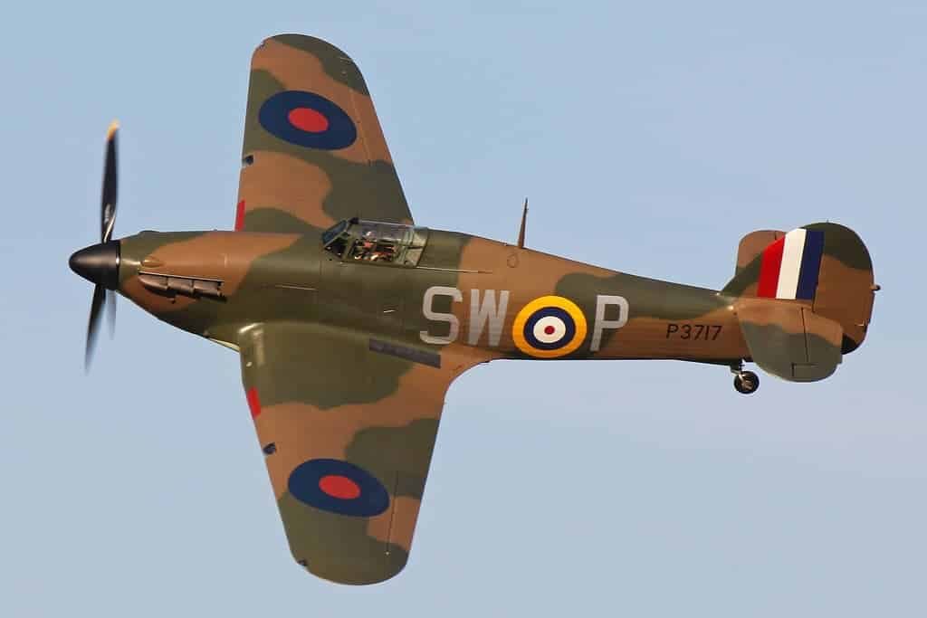

**World War 2**

**French:** As linguists, we will learn how to ask questions about others and introduce ourselves in French.

**Computing:** As computer designers, we will be learning to analyse and review games to use our own feedback to then create and use our own using a programme on Purple Mash to support our learning.

**Religious Education:** As children at Bromesberrow, we will be exploring the following question – ‘For Christians, what was the impact of Pentecost?’ – Through stories and artwork we will ask questions and share ideas on what the impact was. We will the go on to explore the question ‘Why do some people believe in God and some people not?’ Using the knowledge we have gained throughout the year to support our thinking.

**Music:** As musicians, we will be learning to play an instrument (recorders) exploring tempo and reading/learning notes to then perform.

**History:** As Historians, we will be learning about World War 2. We will be looking back at why this war started and the impact it had on the world including the Holocaust. Together, we will learn about the key figures throughout the war, where they ruled and the significance they have within our history. To support this learning, much of what we do in English, art and D.T will be linked to WW2; Propaganda poster making, building miniature Anderson shelters, The Blitz artwork and recount, Fact file writing on evacuees and Anne Frank and looking at how the war impacted our local area. Towards the end of the Summer Term we will be having a WW2 day with lots of exciting activities to further learn about this significant event in our history.

**Maths:** As Mathematicians, we will be developing our understanding of shape and measure, time, money and statistics. Throughout our Maths lessons we will follow; Skill it (Fluency), Apply it (Reasoning) and Deepen it (Problem Solving) to fully share our understanding. Our Number Master Sessions will focus on previous years learning to fully embed understanding.

**Science:** As Scientists, we will be exploring ‘Animals including humans’. We will be learning all about the body (teeth, digestive system, and circulatory system) and how bodies change as they age and why/how this happens. Throughout making comparisons between different animals and thinking carefully about why processes are different depending on the animal; linking to their environment and touching on the evolution and inheritence of these animals.

**Physical Education:** As sports people, we will be having weekly sessions with Worcester Warriors to enhance our rugby skills. We will also be having an afternoon a week in Forest School using our fine and gross motor skills to climb, build and problem solve throughout a range of activities.

**BV/SMSC:** As citizens, we will be compassionate towards others and their opinions, thinking carefully about what we can say to others in times of disagreement. Thinking carefully about the world in which we live and how we can respect our environment and others.

**PSHE:** As caring members of the community, we will be enhancing our team work and conflict resolution throughout our Forest School sessions, using this as an opportunity to adapt and respond to others and their needs. Further developing our understanding on how we can keep safe online, at home and by water.

**English:** As Writers, we will be using the text Rose Blanche by Robert Innocenti and Ian McEwan to support our writing and learning. We will be using Rose Blanche to inspire us in writing for a range of purposes; to entertain and inform. Further using this text to explore why writers and illustrators make the choices they do and using this within our own writing. Throughout, we will use our punctuation and grammar knowledge to successfully share ideas in our writing and explore how to link our writing together more successfully with a range of figurative language and techniques to build tension and suspense. Further learning about; formal and informal language, relative clauses, pronouns, commas to clarify meaning, paragraphs and Commas/brackets/ dashes to indicate parenthesis**.** Our spelling will focus around strategies to remember words from the statutory spelling list, words ending ‘ar/er’ and homophones and adding prefixes and suffixes. During our guided reading sessions we will be using a range of age appropriate texts to support our learning of decoding, retrieval, explanation, interpret and choice.