Mastery and working at Greater Depth in Learning

What does Greater Depth look like at Bromesberrow?

Bloom’s Taxonomy
Bloom’s Taxonomy of learning model clearly identifies the different stages of knowledge which children can demonstrate their level of understanding.
In order for a child to be considered to be achieving a level of mastery and depth, they will show they can apply their knowledge to tasks designed with creating, evaluating or analysing as an objective.

Bloom’s Taxonomy Learning Model

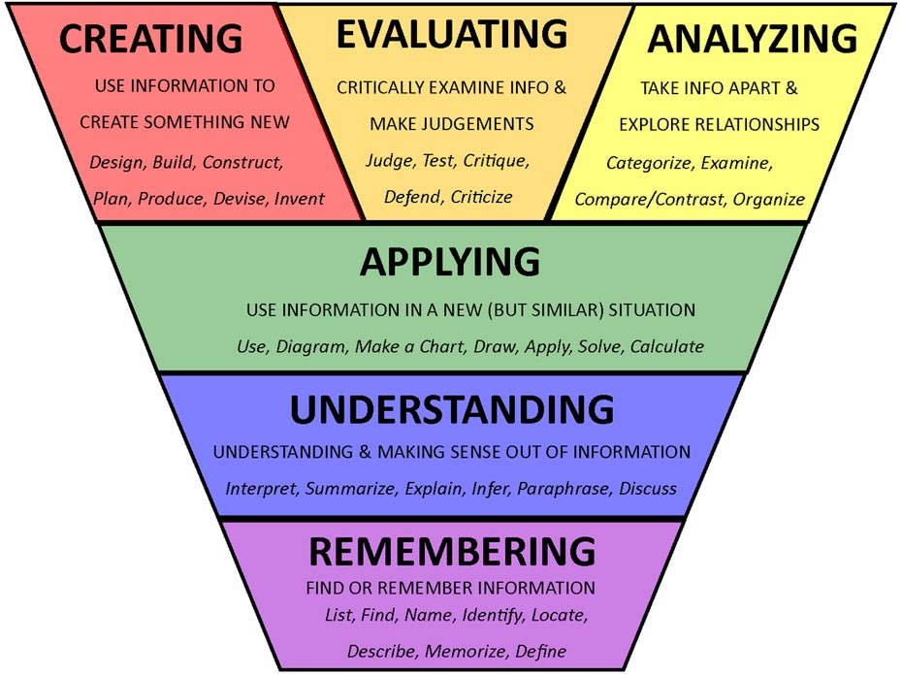

Using the previous method of assessing pupils using levels, children who were exceeding a particular level would have moved up into the next level band, studying the next year group’s objectives. The DfE now require children who are exceeding their year group expectations to add more depth and breadth to their learning, and to have more opportunities to develop how they use and apply their skills. They are calling this phase of learning Mastery and Depth.

Process of Learning Model

Learning behaviours to look out for in the classroom *indicative of greater depth learning
Explain and teach a concept to others.
Return after a break and still have the knowledge and skills
Organise ideas, being able to make connections with different areas and learning. Combine ideas and evolve.
Use skills and knowledge consistently on different occasions in different contexts.

