Guided Reading at Bromesberrow
We use the DERIC Approach developed by Rhona Wilson to plan and teach reading explicitly at Bromesberrow. All of our texts are carefully chosen and planned in advance, from Preschool through to Year 6, to ensure that the children’s reading diet is broad and balanced. The texts chosen and the level of questioning is progressive throughout the school, so that learning is cumulative.
The DERIC Approach uses specific, planned questions based around:
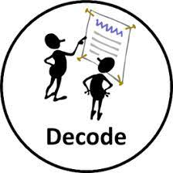
Reading activities to give children an opportunity to apply their phonic knowledge
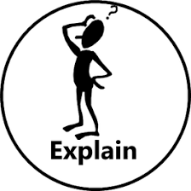
Reading Activities to develop children’s understanding of vocabulary and understanding of whole texts
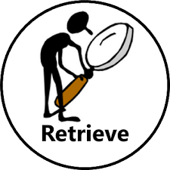
Reading Activities to develop children’s ability to retrieve information from the text
Reading Activities to develop children’s ability to discuss author choice and their own choices, making connections to their experiences, other books and the world around them
Reading Activities to develop children’s ability to interpret information from the text

Whole school consistent approach
Non negotiables
Each class will display DERIC symbols
All staff to be confident and conversant in this terminology
DERIC terminology and language to be used with and understood by the children
Guided reading will be planned
One quality guided reading session to happen each week
Guided Reading book for Year 1 upwards
A selection of fiction, non-fiction, poetry and play scripts should be used. If appropriate texts can be chosen to enhance learning in other curriculum areas e.g. geography, science and history through non- fiction choice.
Early Years
In the Early Years, preschool and reception, DERIC involves a weekly planned session, using a predetermined quality text. The teacher has 2- 3 questions planned prior to the session based upon DERIC.
Children have regular story times and ‘vote’ upon class stories. Story time is a special time, where the whole class comes together to share, experience, enjoy and connect.
In addition to this, we have quality texts as part of our continuous provision. The children are encouraged to explore these independently, using the props and stimuli on offer. The role of the adult is to challenge children in their reading and comprehension, through quality adult-child interactions.
This is how a shared/guided reading session may look using The Little Red Hen:
We initially try to interest the children in the text, providing a purpose for reading- a little hook e.g. “Today we are going to look at a book about a Little Red Hen, who bakes some delicious bread. We are going to find out how she made this from a tiny seed.”
We may then try to relate the story to the children’s own experiences e.g. “who has made bread here? Can you remember what ingredients you needed for this?”
We may then look at the front cover and see if we can predict anything from this e.g. “which characters do you think the Little Red Hen may meet?”
As we read the text we will have thought carefully and planned some questions (only one per DERIC) to ask the children along the lines of:
“Can you hear/read the sound at the beginning of this word?” (hen)
“Can you read this tricky word?” (little)
“Can you hear two words that sound the same (rhyme)?” (cat and rat)

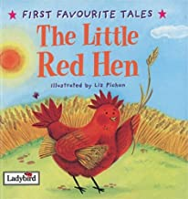

“ What do you think the word ripe means?”
“ Why do you think the Little Red Hen was VERY pleased with herself and not just pleased?”
“I have some challenge words (put up at the beginning) can you hear then and give me a signal as I am reading? Can anyone act out this word?”E.g. mumbled, sniffed and snorted.

“ Can you find a word that describes the rat on this page?” e.g. skinny, sleek
“ What was the little red hen doing before she found the ear of corn?”
“What did the little red hen have to do to the corn every day to help it to grow?

“What kind of character is the little red hen?” e.g. is she kind, mean, sad, hard working? Give children choices.
“How would you describe the pig?” give two opposite words and the children need to vote.
“How do you think the animals are feeling at the end and why?

At this age we focus on the child’s choice, rather than authorial intent. This is developed in year 2
“Do you like this book? Why?”
“What is your favourite part?”
“What would you like to happen next?” Discuss in relation to one of the characters.

In Ks1 (Year One and 2), we build upon this to have a focused guided reading session each week. In year One they will be taught as a class group using one text, with DERIC focused tasks from this. The children will be expected to record their answers in their guided reading books. There must always be a Decode. Teacher to focus on three DERIC’s as a maximum e.g.
Using Titch by Pat Hutchins:
Why do you think Titch had a sad face when he was holding his pinwheel?

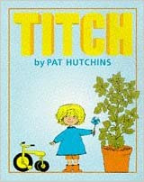
Can you change the word ‘big’ to ‘bigger’ and ‘big’ to ‘biggest’?

What happened to Titch’s Tiny seed?

In Year 2, the expectations would be increased through the questions used, although CHOICE and author intent should be introduced as the year progresses. Texts are not chosen as individual readers are. There is no call for 95% accuracy, as teacher often reads the text, with key children selected to read captions, sentences and words, dependent on the child’s ability level e.g.
Using Lazy Lion by Mwenye Hadithi:
On page 9: Can you hear the word ‘huge’ as I read. How would I spell this?

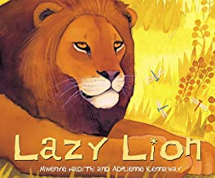

What materials did the Weaver Birds use to build their nests?

Why do you think Lion didn’t want to live in the tree trunk?

In Ks2 (Years 3-6), the format should be similar, however the expectation will be increased, in terms of challenge of questioning. Children will use picture books, poems and chapter books.

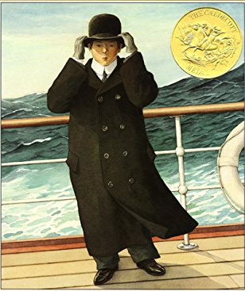
What does the word ‘perilous’ mean?

Why do you think the man is holding onto his hat?

How has the illustrator shown that the sea is rough?

Quality Text Planner
These are the pre-planned quality texts for across the school. Texts have been chosen carefully to coincide with learning in different curriculum areas- this broadens and deepens understanding; to develop children’s cultural capital and just because they are a ‘great’ book. A lot of research has gone into the selection of these.
Class One | Autumn A | Spring A |  | Summer A
Class 1  Preschool and Reception | Preschool and Reception- Weekly focused text (story telling) with DERIC questions planned prior to reading  Non Fiction texts:  Animal Homes by Libby Waldon  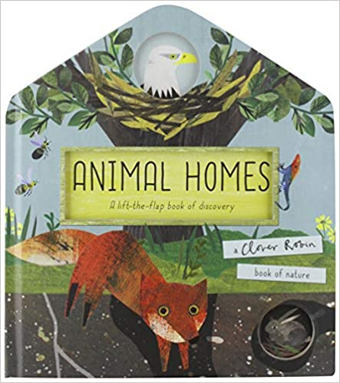  Tree by Britta Treckentrup  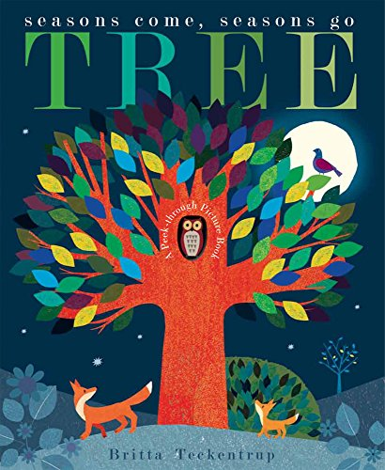  Prickly Hedgehogs by Jane Mcguiness  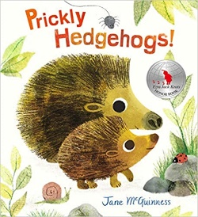  Fiction texts:  Dear Zoo by Rod Campbell  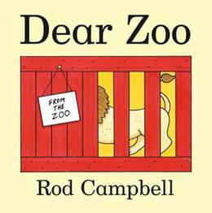  The Very Hungry Caterpillar by Eric Carle  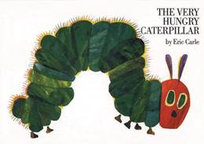  The Tiger who came to Tea by Judith Kerr  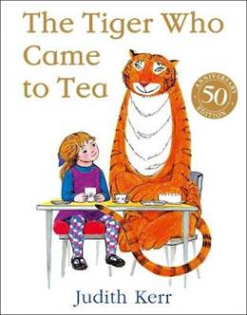  Stickman by Julia Donaldson  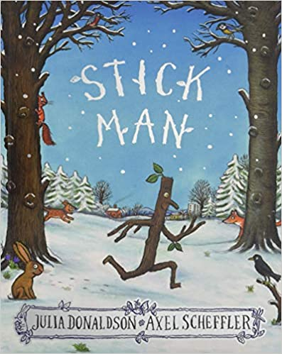  Lost and Found by Oliver Jeffers  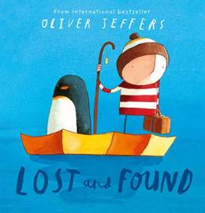  The Little Red Hen by Ladybird  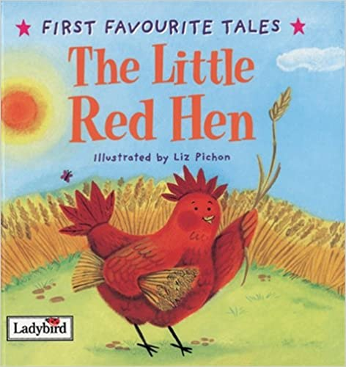  Peepo by Janet and Alan Ahlberg  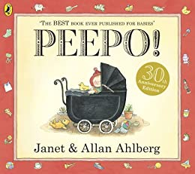  The Snowman by Raymond Biggs  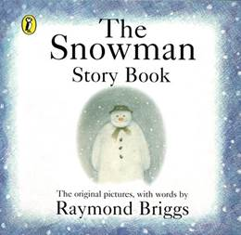  The Nutcracker  Twelve Days of Christmas by Britta Teckentrup  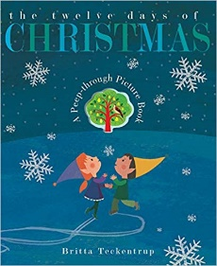 | Preschool and Reception- Weekly focused text (story telling) with DERIC questions planned prior to reading  Non Fiction Texts:  Yucky Worms by Vivian French  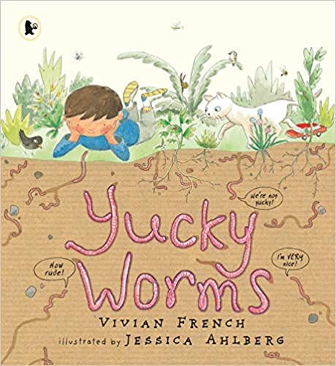  Bird House by Libby Waldon  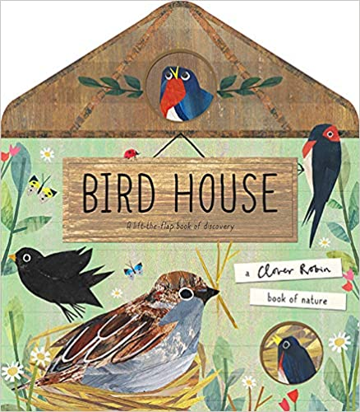  Moon by Britta Teckentrup  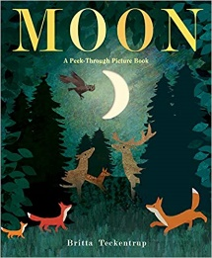  Are you a Butterfly? By Judy Allen  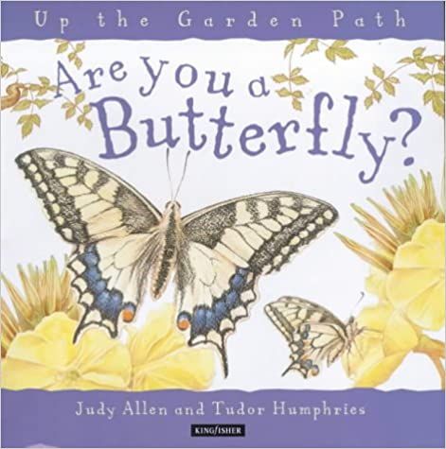  Seeds Move by Robin Page  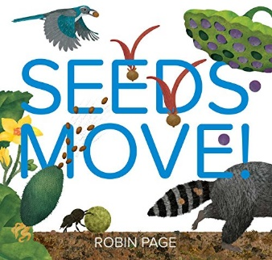  Fiction Books:  We’re Going on a Bear Hunt by Michael Rosen  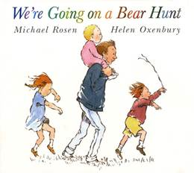  Goldilocks and the Three Bears  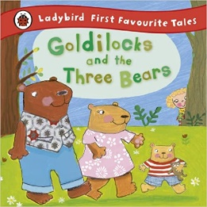  Barry the Fish with Fingers by Sue Hendra  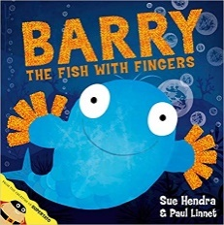  The Colour Monster by Anna Llenas  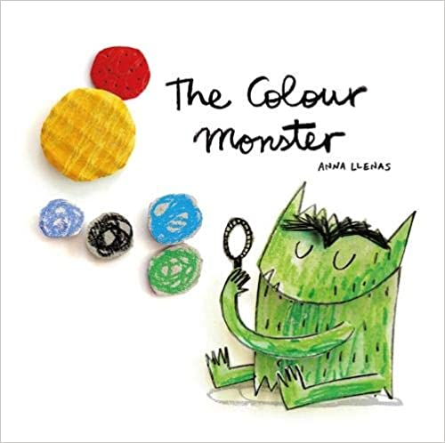  Hairy Maclary from Donaldson’s Dairy by Lynley Dodd  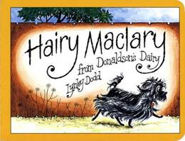  Not Now Bernard by David Mckee  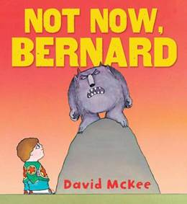  I Want my Hat Back by Jon Klassen  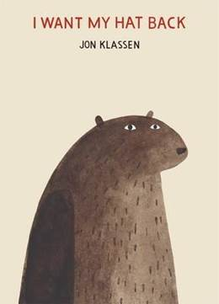 |  | Preschool and Reception- Weekly focused text (story telling) with DERIC questions planned prior to reading  Non Fiction Texts:  Bug Hotel by Libby Waldon  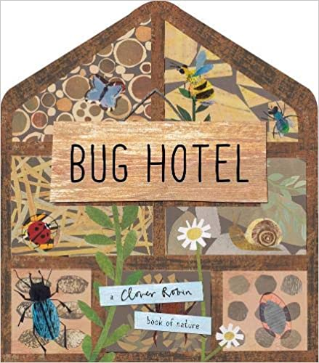  Secrets of the Seashore by Carron Brown  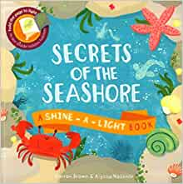  Dogs in Space by Vix Southgate  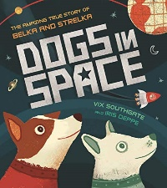  Laika the astronaut by Owen Davey  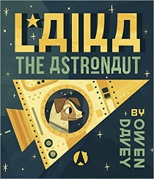  What Do you Do with a Tail like this? By Steve Jenkins  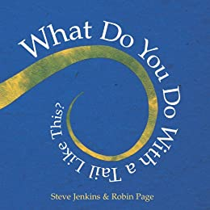  Are you a Bee? By Judy Allen  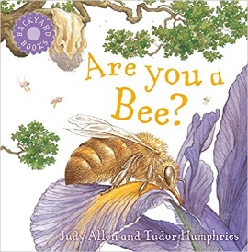  Fiction Books:  Farmer Duck by Martin Waddell  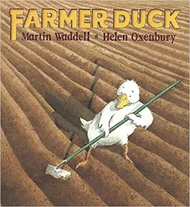  Mr Gumpy’s Outing by Jon Burningham  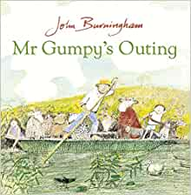  Where the Wild Things Are by Maurice Sendak  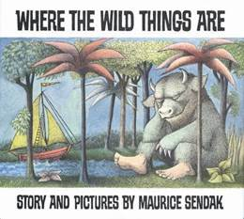  Handa’s Surprise by Eileen Browne  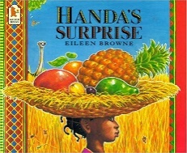  The Three Little Pigs  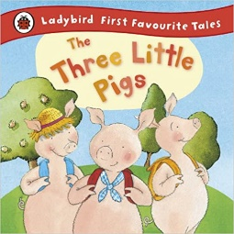  The Proudest Blue by Ibtihaj Muhammad  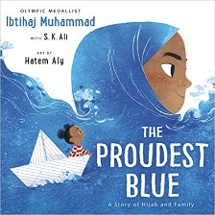
Preschool and Reception | Autumn B | Spring B |  | Summer B
 | Goodnight Owl by Pat Hutchins  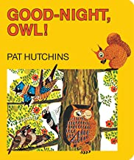  Saturday Night at the Dinosaur Stomp by Carol Diggory Shields  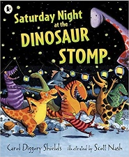  The Owl who was Afraid of the Dark by Jill Tomlinson  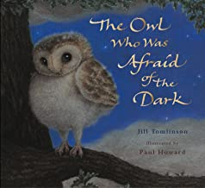  Aliens Love Underpants by Claire Freedman  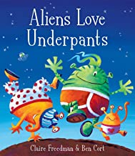  Not Just a Stick by Antoinette Portis  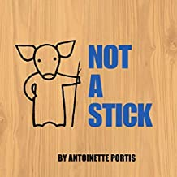  The Squirrels who squabbled by Rachel Bright  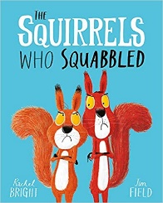  Hairy Maclary Rumpus at the Vets by Lynley Dodd  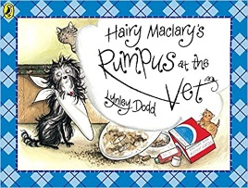  Non Fiction  Bee by Britta Teckentrup  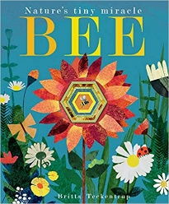  Who’s Hiding at the Seaside? By Katherine McEwen  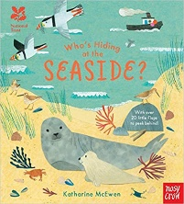 | All are Welcome by Alexandra Penfold  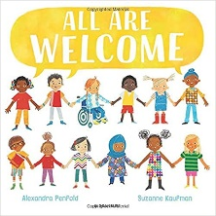  Room on a Broom by Julia Donaldson  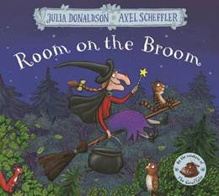  Here we are Are by Oliver Jeffers  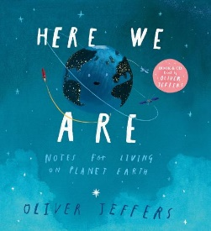  Suddenly by Colin McNaughton  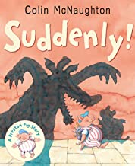  The Enormous Turnip  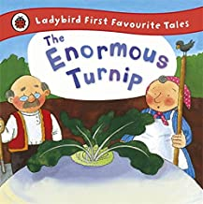  Cockatoos by Quentin Blake  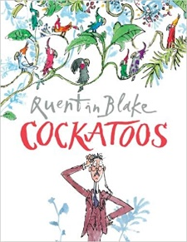  Baby Goes to Market by Atinuke  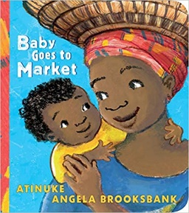  Non Fiction  A Walk through Nature by Colver Robin (3 weeks of sessions)  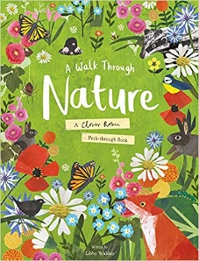  Who’s Hiding in the River? By Katherine McEwen  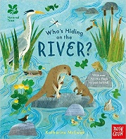 |  | Little Red Riding Hood  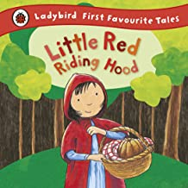  Rapunzel by Bethan Woollvin  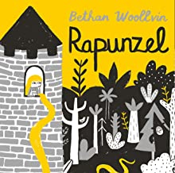  Meg and Mog by Helen Nicholl  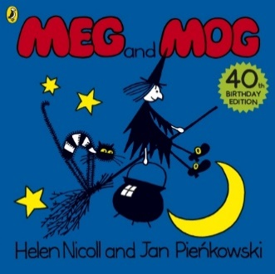  The Storm Whale by Benji Davies  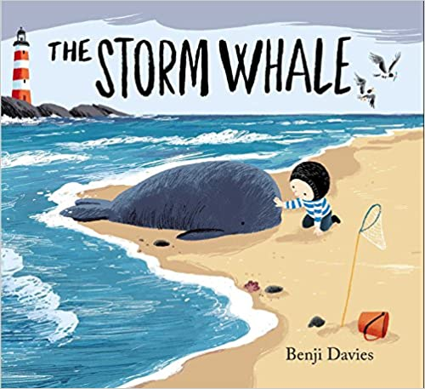  Non fiction  The Big Book of Bugs by Yuval Zommer (a page per session over 6 weeks)  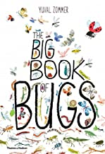
Class One | Autumn A | Spring A |  | Summer A
Year One | Year One-A book focus per term  Non- fiction-Y1  Let’s Go back into History by Timothy Knapman  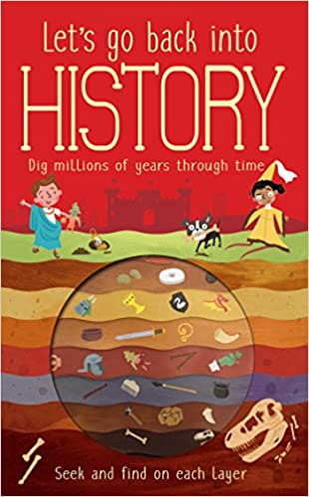  Fiction- Y1  The Snail and the Whale  (links to Seaside, history)  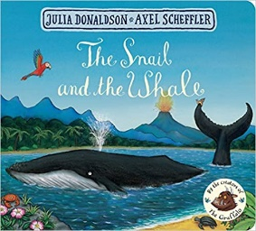 | Year One-A book focus per term  Non Fiction -Y1  The Big Book of Blue by Yuval Zommer  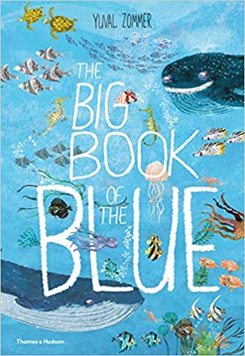  Fiction-Y1  The Last Wolf by Mini Grey  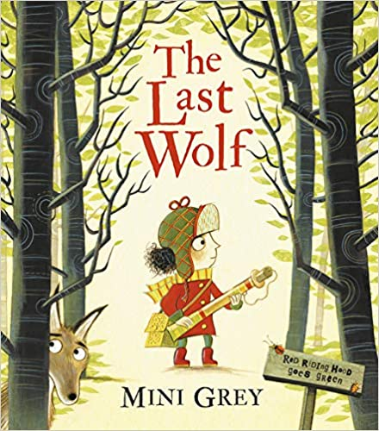 |  | Year One-A book focus per term  Non Fiction-Y1  Let’s Go into Space by Timothy Knapman  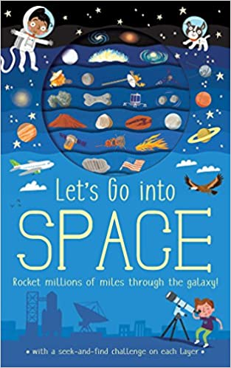  A Year On the Farm by Adam Henson  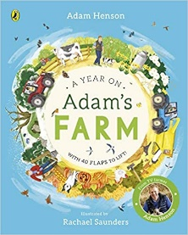
Class Two | Autumn A |  | Spring B |  | Summer B
Class 2  (2021/2022) | Autumn 1 (Topic Great Fire of London)  Non Fiction- Y3  The Great Fire of London  Anniversary Edition of the Great Fire 1666 by Emma Adams and James Weston Lewis (links to History learning)  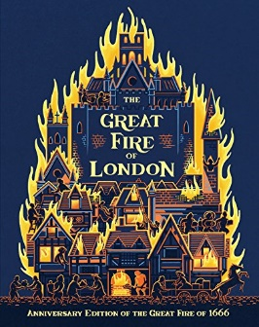recieved  Poetry- Y3  Fire  Poem 1: 1 session  In the corner of the room  The fire flickers fiercely:  Flames form fingers  That rise and fade Faster than thoughts -  The shapes they make  Cast faces in my mind,  Like sudden memories of long lost friends. By David Windle  (focus alliteration and imagery)  Poem 2:  Firework Night  1-2 sessions  BANG!  What’s that?  Bang-Bang!  Oh, Hark, The guns are shooting in the dark!  Little guns and big ones too,  Bang-bang-bang!  What shall I do?  Mistress, Master, hear me yelp,  I’m out-of-doors,  I want your help.  Let me in - oh,  LET ME IN  Before those fireworks begin  To shoot again - I can’t bear that;  My tail is down, my ears are flat,  I’m trembling here outside the door, Oh, don’t you love me anymore? BANG! I think I’ll die with fright Unless you let me in to-night.  (Shall we let him in, children?)  Ah, now the door is opened wide, I’m rushing through,  I’m safe inside,  The lights are on, it’s warm and grand - Mistress, let me lick your hand  Before I slip behind the couch. There I’ll hide myself and crouch In safety till the BANGS are done - Then to my kennel I will run  And guard you safely all the night Because you understood my fright.  By Enid Blyton  A Ray of Light by Walter Wick (links to Science Light) 4 weeks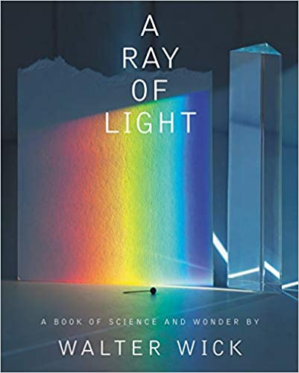  Fiction- Y2  Amazing Grace by Mary Hoffman and Caroline Binch (6-7 weeks)  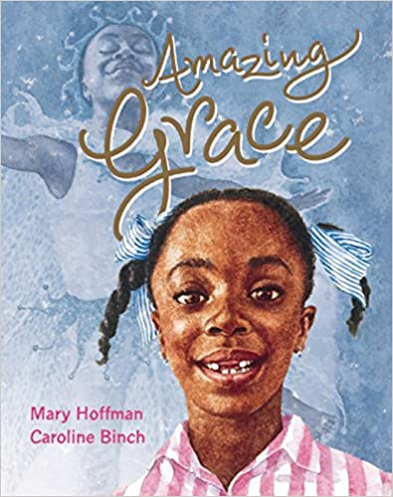  Fiction Y2- (6-7 weeks) The Things that I love about Trees by Chris Butterworth and Charlotte Voake  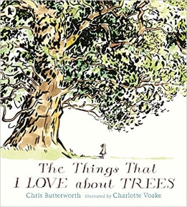 | Spring 1 (Topic: Volcanoes and Mountains  Fiction- Y3  When the Giant Stirred by Celia Godkin (6 weeks) Links with Voracious Volcanoes  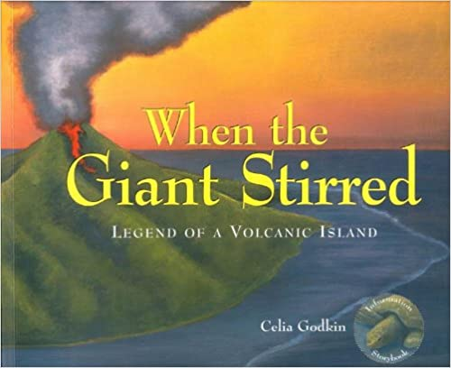  Fiction: Winter’s Child by Graham Baker Smith (6 weeks)  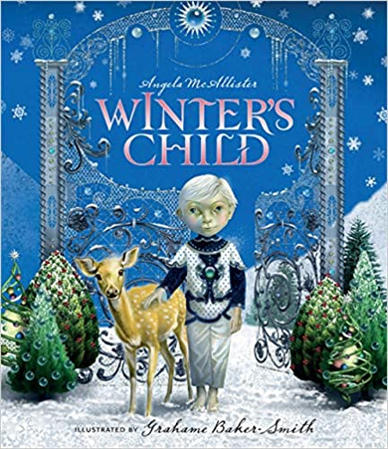 recieved x6  Non Fiction- Y2 Pop up Volcano by Bernard Disuit et al (6 weeks) Links with Voracious Vocanoes  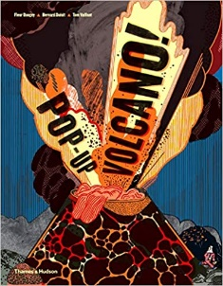 ordered 4  Literacy Shed- The Three Little Pigs  The True Story of the Three Little Pigs by A. Wolf |  | Summer 1 (Vikings, Anglo Saxons and Celts)  Fiction- Y3  The Dragon’s Hoard by Lari Don links with Vikings  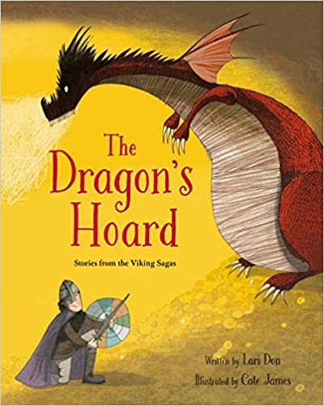received  Non Fiction  Norse Mythology by Heather Alexander  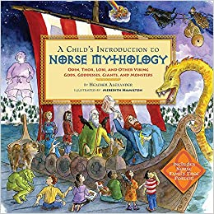 received 4, ordered 1 more  Fiction- Year 2  The Greenling by Levi Pinfold  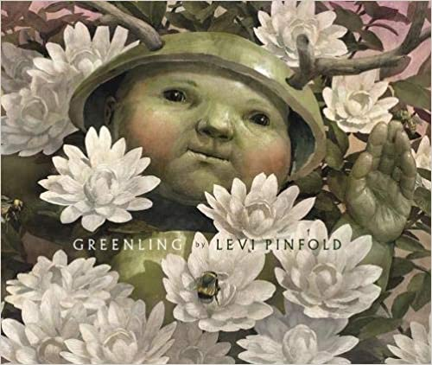 received 6  Poetry-3 weeks  I am the Seed that Grew the Tree (natures poem for everyday)  By Fiona Waters  Pobble 365- 3 weeks  Professor Plum  Teapots  An Unexpected Adventure

Class Two | Autumn B | Spring B | Summer B
Class 2  2021/22 | Non Fiction-Y3 (Topic Stone Age and prehistory)  Skara Brae by Dawn Finch (to link in with Stone Age)  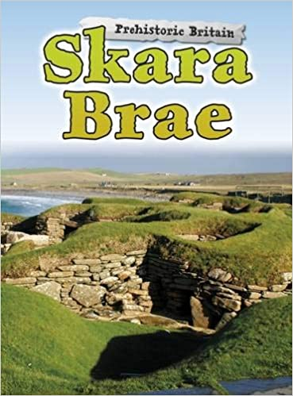  Fiction  Stone Girl, Bone Girl by Laurence Anholt (to link in with Stone Age)  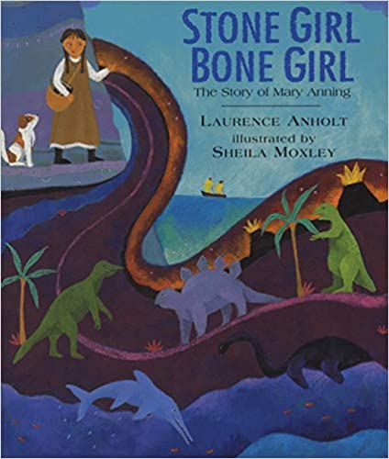  Fiction- Y2  Glog by Pippa Goodheart ( 6 weeks)  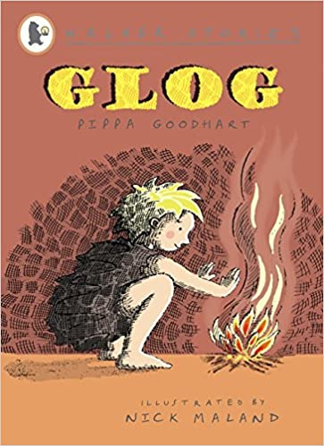  Non Fiction-Stone Age, Bone Age  By Nick Manning and Brita Granstrom  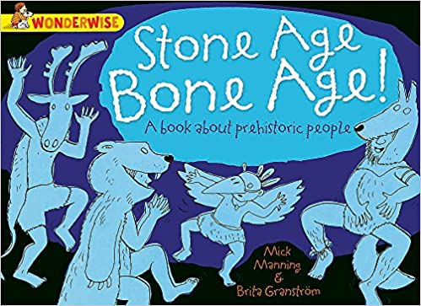 | Non Fiction- Y3 (Around the Word in 80 Ways, the UK and Rivers)  Sticker and Quiz Atlas of Britain by AA Publishing (To link in with Geography)  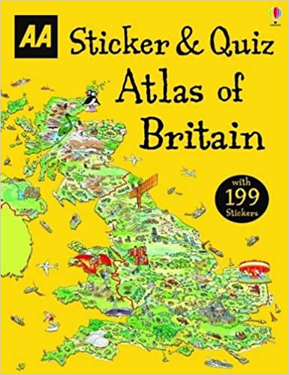  Fiction  A River by Marc Martin (to link in with Water cycle)  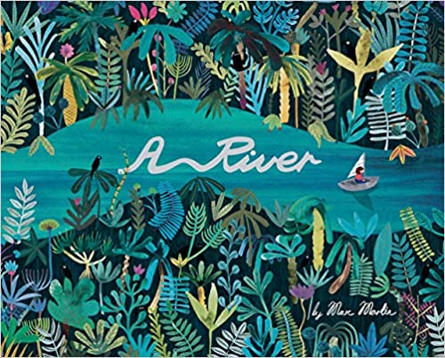  Non Fiction- Year 2  Usborne Picture Atlas by Ruth Brocklehurst. To link in with geography (6 weeks)  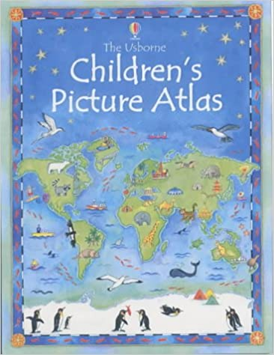  The Rhythm of The Rain by Graham Baker Smith. To link in with Water Cycle (6 weeks)  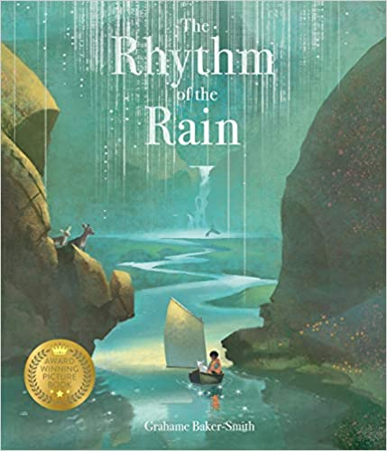 | Non Fiction- Y3 (Topic;: The Romans)  An Anthology of Intriguing Animals by Ben Hoare (to link in with Science Living things)  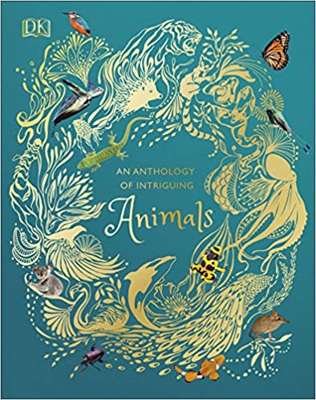  Poetry  Pleasant Sounds by John Clare  The rustling of leaves under the feet in woods and under hedges;  The crumpling of cat-ice and snow down wood-rides, narrow lanes, and every street causeway;  Rustling through a wood or rather rushing, while the wind halloos in the oak-toop like thunder;  The rustle of birds’ wings startled from their nests or flying unseen into the bushes;  The whizzing of larger birds overhead in a wood, such as crows, puddocks, buzzards;  The trample of robins and woodlarks on the brown leaves, and the patter of squirrels on the green moss;  The fall of an acorn on the ground, the pattering of nuts on the hazel branches as they fall from ripeness;  The flirt of the groundlark’s wing from the stubbles- how sweet such pictures on dewy mornings, when the dew flashes from its brown feathers!  Non Fiction- Y2  See Inside Ancient Rome by Katie Daynes Link with history)  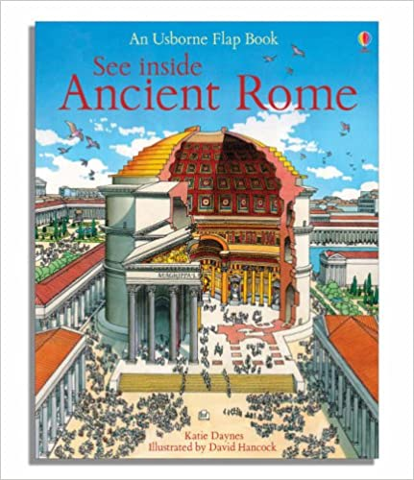  Poem 1 (3 weeks)  The Owl and the Pussy Cat by Edward Lear
Class Three | Autumn A | Spring A | Summer A
Class 3  2021/22 | Autumn 1 (Topic: Ancient Greece)  Whole class:  Non Fiction: So you think you’ve got it bad? A Kids life in Ancient Greece by Chae Strathie  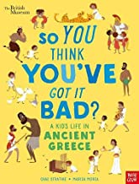  Autumn 2  Whole Class:  Non Fiction:  Orchard Greek Myths – Geraldine McCaughrean  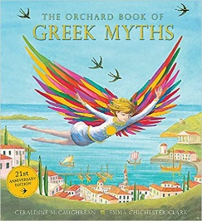 | Spring 1 (Topic: The World Around us)  Group 1 (Y6) :  Fiction: Journey to Jo’burg – Beverly Naidoo  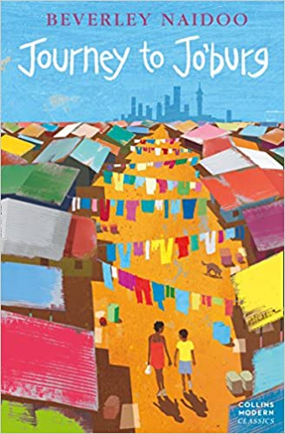  Group 2 (Y5/6): Journey to the River Sea – Eva Ibboston  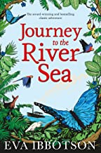  Group 3 (Y4/5): To the edge of the world – Julia Green  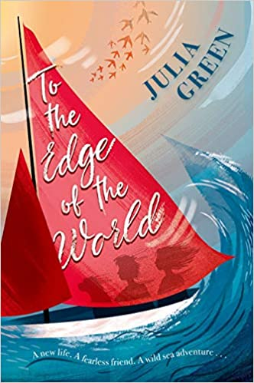  Group 4 (Y4): Explore  Spring 2: Whole Class: Atlas of Adventures (wonders of the world) by Ben Handicott  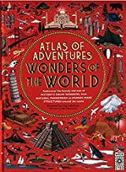  Group 1: SATs Practice | Summer 1 (Topic WW2)  Group 1 (Y6): Boy in Striped Pyjamas  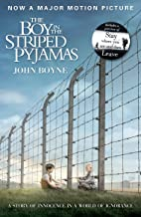  Group 2 (Y5/6): Once – Morris Gleitzman  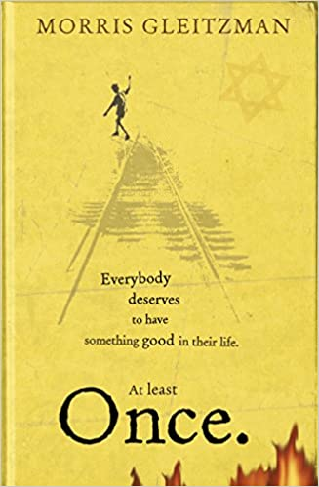  Group 3 (y4/5): When Hitler stole pink Rabbit – Judith Kerr  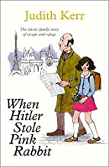  Group 4 (Y4/5): Wild Waters
Class Three | Autumn B | Spring B | Summer B
Class 3  2022/23 | Autumn 1: Whole Class: Emmeline Pankhurst – Little People, Big Dreams – Lisbeth Kaiser (non-fiction)  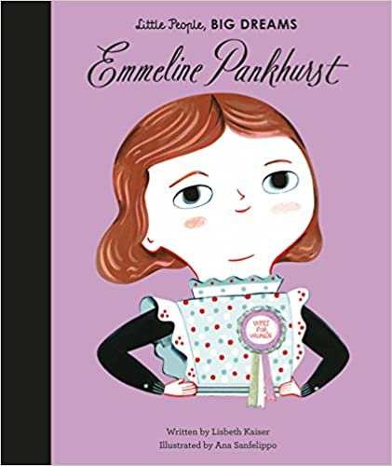  Autumn 2: Whole Class: Oceans, Not so plastic fantastic – Trevor McCurdie  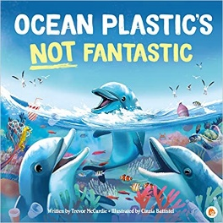 | Spring 1:  Group 1 (Yr 6): SATs Practice  Group 2: (Yr 5): The firework makers daughter – Phillip Pullman  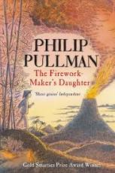  Group 3: (yr 4): Charging about: The story of Electricity (Science works) – Jacqui Bailey  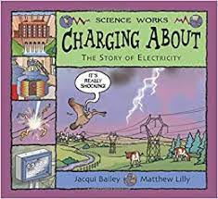  Spring 2: Whole Class:  Hiawatha Traditional Tale  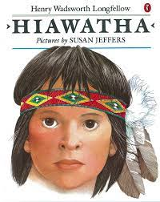 | Summer 1:  Group 1 (Yr 6): Romeo and Juliett – Shakespeare / SATs practice  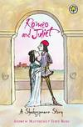  Group 2 (Yr 5): Beowulf by Michael Morpurgo  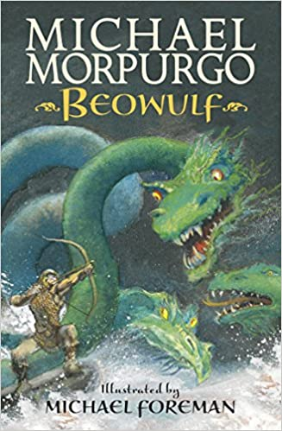  Group 3 (Yr 4): Nelson Mandela, Long walk to freedom by Chris Van Wyk.  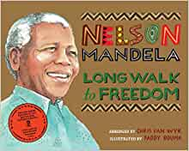
Class Three | Autumn C | Spring C | Summer C
Class 3  2023/24 | Autumn 1: Whole Class: The great Kapok Tree by Lynne Cherry  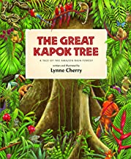  Autumn 2: Whole Class: Old enough to save the planet by Anna Taylor and Loll Kirby  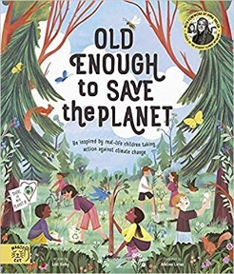 | Spring 1:  Group 1 (Yr 6): River Boy by time Bowler  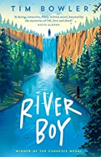  Group 2 (Yr 5): The wind and the willows by Kenneth Grahame  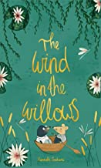  Group 3 (Yr 4): River Stories: Explore the sights and stories of the world’s five greatest rivers by Timothy Knapman  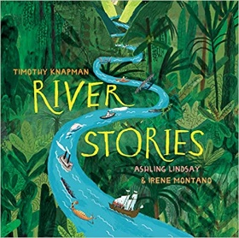  Spring 2: Whole Class The Mysteries of the universe: Discover the best-kept secrets of space.  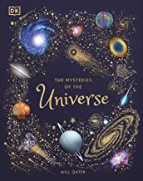  Group 1: SATs Practice | Summer 1:  Group 1 (Yr 6): Poppy Pym and the Pharaoh’s Curse by Laura Wood.  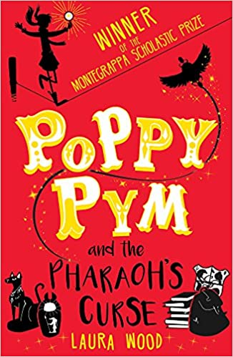  Group 2 (Yr 5): Cinderella of the Nile by Beverley Naidoo  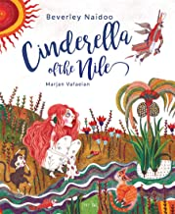  Group 3 (Yr 4): Marcy and the riddle of the sphynx by Joe Todd Stanton  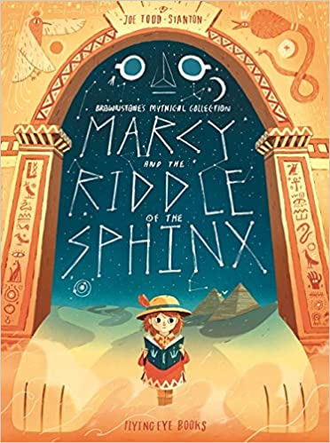  Summer 2: Whole Class: So you think you’ve got it bad? Ancient Egypt by Chae Strathie and Marisa Morea  